1. **Screenshots**
   1. **Screen 1 : Add risk factor and living arrangement details to intake so that they are visible on Maltreatment screen.**

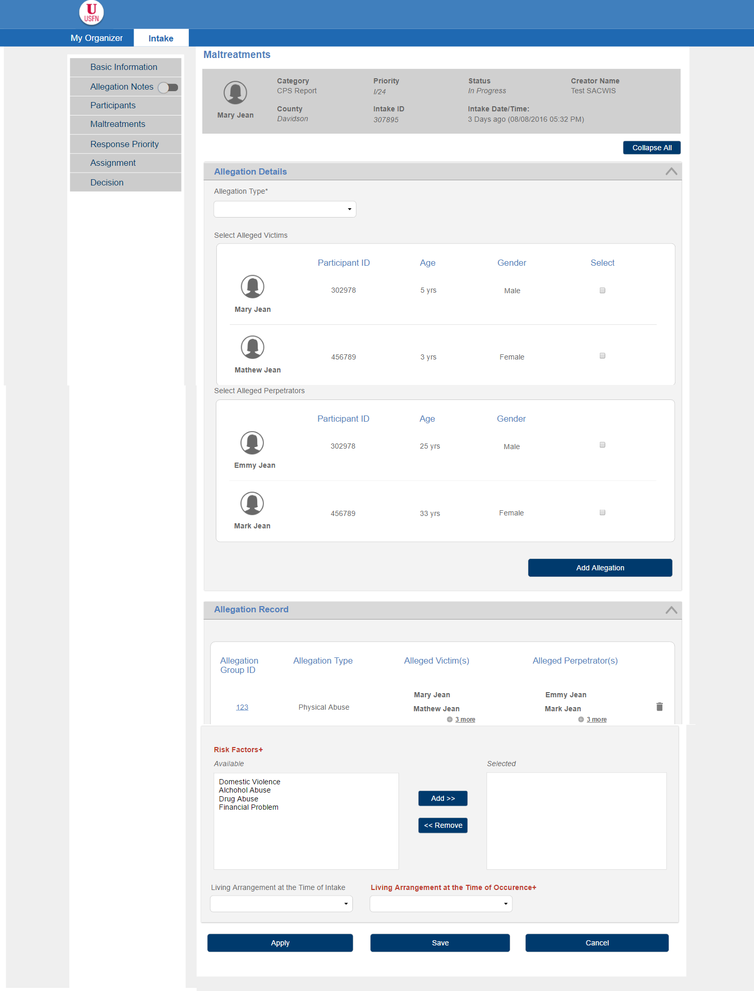

* + 1. **Screen Fields**

| **Class.Attribute Name** | **Display Name** | **Type** | **Align** | **Size** | **Read**  **Only** | **Calculation** | **Edit Mask** | **To Be**  **UI Validation** |
| --- | --- | --- | --- | --- | --- | --- | --- | --- |
| N/A | Risk Factors | Group Label | L | 100 | T | N/A | N/A | N/A |
| INTAKE_CHARACTERISTIC.intakeCharacteristicCode | Available | Mover box | L | 30 | T | Domain Code = “CaregiverRiskFactor” | N/A | System populated  User selectable  Not mandatory |
| N/A | Selected | Mover box | L | 100 | T | N/A | N/A | User selected |
| INTAKE.livingArrangements | Living Arrangement at the time of intake | Drop down | L | 100 | F | Domain Code = LivingArrangement where parent ref data code = NCANDS | N/A | User selected  Not required |
| ALLEGATIONSETTING.allegationLivingArrangement | Living Arrangement at the time of occurrence | Drop down | L | 100 | F | Domain Code = “LivingArrangement” where parent ref data code=NCANDS | N/A | User selected  Not Required  AFCARS/NCANDS/NYTD |

­­

* + 1. **Action Buttons/Hyperlinks**

| **Label** | **Type** | **On Click Action/Navigation** |
| --- | --- | --- |
| Apply | Button | Data is saved and user remains on the screen |
| Save | Button | All cached screen data will be committed to the database. User returns to the Intake Workload Screen |
| Cancel | Button | Return to Intake Workload Screen; no newly entered data will be saved. |

**2. Story**

As an Intake Worker I should be able to add risk factor and living arrangement details to intake so that they are visible on Maltreatment screen.

**3. Notes**

**3.1 Points to Note**

1. Ignore ‘collapse all’ icon from the prototype.

**3.2 Demo Steps**

**A. To add Risk Factors and Living Arrangement**

1. Login to the USFN application with the following credentials

Username: samweaver

Any Password works.

1. The My Organizer is displayed after successful login.
2. Select ‘Intake’ from the top menu in the My Organizer Screen. The Intake Workload screen is displayed.
3. Select ‘Add CPS Intake’ button on the Workload screen.
4. Screen 1: Basic and Reporting Person Screen is launched.
5. Select ‘Maltreatment’ option from the left hand menu
6. It displays the IN01b-User Story 18, Screen 1.
7. Select the Allegations, victims and Perpetrators and select ‘Add Allegation’ button
8. The Allegation record is added in the Allegation Record table and the fields ‘Allegation Type’, ‘victim’, Perpetrator’ are cleared.
9. Add Risk Factors and Living Arrangement information on the screen and save the maltreatment screen.

**4. Acceptance criteria**

|  |  |  |  |
| --- | --- | --- | --- |
| # | Requirement | Execution Event | Status |
| 1 | The user should be able to save the Risk Factors and the Living Arrangement Information | Apply/ save |  |

**5. Seed Data**

1. Drop Downs: ‘Living Arrangement at the time of Occurrence’, ‘Living arrangement at the time of Intake’

|  |  |  |  |  |  |  |  |  |  |
| --- | --- | --- | --- | --- | --- | --- | --- | --- | --- |
| **Domain Code** | | **Sort Order** | | **Reference Code** | | | **Display Value** | | |
| LivingArrangement | | 40 | | | MARRIEDTWOPARENTBOTHBIOADOPT | | | 01=Married two parent household, with two biological/adoptive parents |
| LivingArrangement | | 41 | | MARRIEDTWOPARENTONEBIOADOPT | | | 02=Married two parent household with one biological/adoptive and one step parent | |
| LivingArrangement | | 42 | | | UNMARRIEDTWOPARENTBOTHBIOADOPT | | | 03=Unmarried two parent household with two biological/adoptive parents |
| LivingArrangement | | 43 | | UNMARRIEDTWOPARENTONEBIOADOPT | | | 04=Unmarried two parent household with one biological/adoptive parent and one cohabitating partner | |
| LivingArrangement | | 44 | | | TWOPARENTHOUSEHOLD | | | 05=Two parent household, marital status unknown |
| LivingArrangement | | 45 | | SINGLEPARENTMOTHER | | | 06=Single parent household, mother only | |
| LivingArrangement | | 46 | | | SINGLEPARENTFATHER | | | 07=Single parent household, father only |
| LivingArrangement | | 47 | | SINGLEPARENTMOTHERANDOTHER | | | 08=Single parent household mother with other adult (grandparent, uncle, aunt, unrelated adult, etc.) | |
| LivingArrangement | | 48 | | | SINGLEPARENTFATHERANDOTHER | | | 09=Single parent household father with other adult (grandparent, uncle, aunt, unrelated adult, etc.) |
| LivingArrangement | | 49 | | NONPARENTRELATIVECAREGIVER | | | 10=Non-parent relative caregiver household (includes relative foster care) | |
| LivingArrangement | | 50 | | | NONRELATIVECAREGIVER | | | 11=Non-relative caregiver household (includes non-relative foster care) |
| LivingArrangement | | 51 | | GROUPHOMERESIDENTIAL | | | 12=Group home or residential treatment setting | |
| LivingArrangement | | 52 | | | OTHERSETTING | | | 88=Other setting (hospital, secure facilities, etc.) |
| LivingArrangement | | 53 | | UNKNOWN | | | 99=Unknown | |